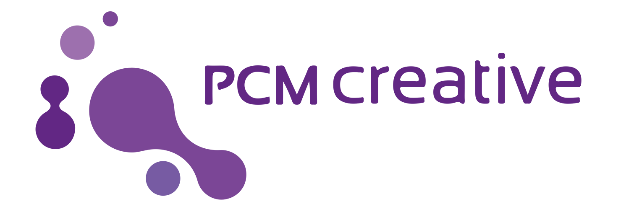

FREE Workshop: Friday 19th July | Derby QUAD - Participation Space | 10 am - 1 pm
BOOK A PLACE VIA EVENTBRITE - bit.ly/utopiaquad

Workshop for Participatory Arts Practitioners in the Midlands

How many times in the last 7 days have you heard, read or used the words, Participation, Immersive, Safe Space, Diversity, Inclusive, Reasonable Adjustment, Non-participant or Accessibility? I am sure you can continue this list of the zeitgeist, funding-friendly buzzwords.

PCM creative’s Caron Lyon would like to invite you to meet London based UtopiaArts’ Frances Rifkin on the morning of Thursday 19th July, who is extending her consultancy programme for arts and community organisations to explore potential opportunities in the Midlands.

Although London remains the main hub for the country's creative businesses the East Midlands experienced a 54 per cent increase in employment. UK CREATIVE JOBS AND EXPORTS GROWTH STATS - July 2017

Why You?
Caron says this,
“After joining in conversations with fellow attendees at two EMPAF expeditions showcasing participation the question of audience and practitioner wellbeing, mental health and duty of care were discussed. I knew you should all be introduced to Fran. I’m delighted Derby Quad’s Participation Curator, John Whall agrees”

Did you attend - Here are Caron's mini-vlogs from the events.
#digitalpARTicipationis the illusion of choice. - LEVEL April 2019
Digital Participation is… QUAD July 2018

Learning through participation is, in essence, the nature of a workshop. Frances Rifkin would like to meet you for this workshop where you can gain an insight into what UtopiaArts can bring to your organisation internally and to your external practice.

Interested?
There are 20 places to explore collaborative partnership possibilities. This is a complimentary workshop touching on the practice led training topics UtopiaArts cover.

- Forum Theatre and collaborative theatre practices with professionals and non-professionals
  - Holding Safe Spaces.
  - Working effectively with groups
  - Facilitating,( “Jokering!”), interacting confidently
  - Facilitating Immersion: safe practices
  - Organisational: development - 360-degree reflection and exchange
  - Stress Management

BOOK A PLACE VIA EVENTBRITE - bit.ly/utopiaquad

FURTHER NOTES FROM FRAN.

I began my career at the Royal Court and Royal Shakespeare Theatres in the 70s. In the early 70s, Graham Lucas and I, with others, I set up our own independent company, Recreation Ground, and then worked to unionise and get funding for, the developing Independent Field. This led to arts funding in the 1970s and ’80s and the establishment of Small Scale Theatre, TIE and Fringe Theatre. As I hope you know, conditions, contracts and best practices in these fields are formalised by Equity with the Independent Theatre Council (ITC). Currently, contracts for devised work are being championed by Equity. which is also about to publish and promote a plan for a revised theatre funding structure with a clear reference to the Independent Field.

Graham is a Filmmaker, Producer and Script Writer. His work on ‘Moving Beyond Violence’ was shaped from the applications of Forum Theatre principles of interactive exploration and was built from group and community experience of conflict resolution and peace work across a range of educational and community settings.

Both Graham’s and my work spans forty years. I trained extensively in Theatre of the Oppressed (TOO) with Augusto Boal. Within the structures of TOO, I work with Forum Theatre (FT) across the Independent Theatre sectors and organisationally within the NHS, local councils, Age UK and Trade Unions etc.

Over the last 9 years, I have been working with the Serpentine Gallery which has funded Implicated Theatre, a company of migrants, refugees and others, in collaboration with Unite the Union. Implicated creates immersive and participatory theatrical events inspired by real-life struggles and highlighting social justice. Our ‘Embassy Ball’ and ‘What Country Friend is This’ being examples of performance events. The workshops explore the relationships between political speech and action, the self and the collective and unheard voices.

I have produced this paper Ethics of Participation in Higher Education and collaborated on Performing ethics: Using participatory theatre to explore ethical issues in CBPR (Community Based Participatory Research) “ The project was initiated and coordinated by Sarah Banks, Centre for Social Justice and Community Action, Durham University, working with Frances Rifkin, Utopia Arts, a long-established theatre practitioner in the Boal tradition.”​ This is a 24-page booklet that outlines the nature of Forum Theatre with exercises and games for use in a workshop on ethics in community-based participatory research.

Are you unable to attend? I am keen to explore opportunities outside of London, as a result, I regularly take video calls from those expressing interest in working with UtopiaArts.

To book a video call please use this link. https://calendly.com/utopiaarts/30min

Utopia Arts producer Caron Lyon will ensure you have the necessary technology and confidence to make the most of your call. Calls are being held via Skype or Appear. If you would like additional support or are uncertain which platform to select, please include comments in the box provided when scheduling your call.

Utopia Arts with PCM projects
Caron - Jane Lyon
M: 07889205914
E: utopiaarts@pcmprojects.co.uk

